ModTech 2026 International Conference (11pt)
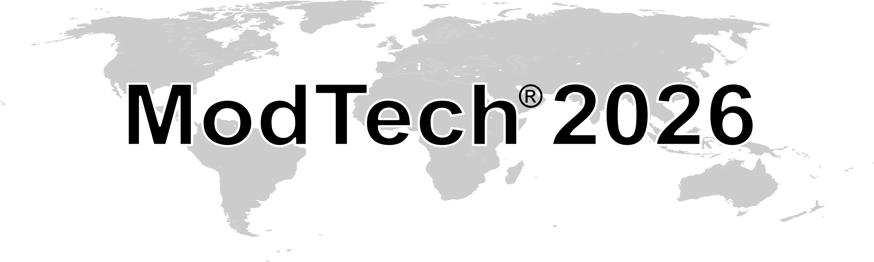
Modern Technologies in Industrial Engineering (11pt)
June 17-20, 2026, Constanta, Romania (11pt)
¶ (11 pt)
¶ (11 pt)
¶ (11 pt)
¶ (11 pt)
instructions for authors and a sample ABSTRACT
(14 pt bold with capital letters, two lines max.)
¶ (11 pt)
First Name Surname¹, First Name Surname ² & First Name Surname ³ (12 pt bold)
¶ (11 pt)
¹Silesian University of Technology, Akademicka 2A, 44-100 Gliwice, Poland
² ”Gheorghe Asachi” Technical University of Iasi-Romania, Department of Machine Manufacturing Technology, Blvd. Mangeron, No. 59A, 700050, Iasi, Romania (10 pt)
³ Technical Sciences Academy of Romania, Bd. Dacia 26, sector 1, 010413, Bucharest, Romania (10 pt)
¶ (11 pt)
Corresponding author (who uploaded the abstract): First Name Surname, E-mail address (10 pt)
¶ (11 pt)
¶ (11 pt)
Abstract (TNR 10pt, bold, italic): Abstract length must be between 350-400 words (10pt). Please take into consideration that the main sentences of the abstract must present the following aspects: placing the work in context; the purpose of the work; explaining what was done (research, methodology); indicating the main results and the most important consequence of the paper. Please use second-name_first-name (of first author)-A-abstract-number.doc for the abstract file upload. The abstracts must be uploaded to www.modtech.ro

Key words (TNR 10pt, bold, italic): List 5-6 keywords (10 pt).

